What Makes Someone a 1099 Vendor?

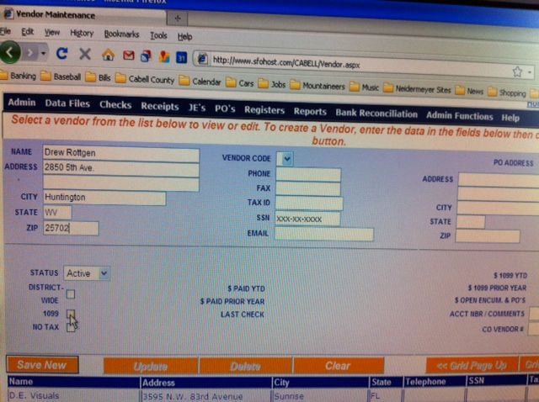

Examples of 1099 vendors: referees, security officers, paramedics, sole proprietorships, partnerships

People and small businesses, NOT WAL-MART

Vendors that qualify as 1099 vendors should fill-out a Form W-9

For questions, please call the business office at (304) 528-5007

